AI BASED GUN PARTS INSPECTION SYSTEM

USING COMPUTER VISION

# KRISHNA SAI K

*Dept of information technology*

*Sri Sairam Engineering College*

Chennai-44

Sec20it064@sairamtap.edu.in

# DR.M SURESH KUMAR

# *Associate professor*

*Dept Of Information Technology*

*Sri Sairam Engineering College*

Chennai-44

Suresh kumar.it@sairam.edu.in

# VARUN ST

*Dept Of Information Technology*

*Sri Sairam Engineering College*

Chennai-44

Sec20it128@sairamtap.edu.in

***Abstract*— Today,** artificial intelligence (AI) is proving to be a **game changer** with **endless** applications in **almost** every field. **Harnessing the power of AI to deliver faster, more accurate, cheaper, and higher quality automation** is now **finding** its way into the **manufacturing sector.** This article **provides a brief introduction** to automated visual quality assessment and how using AI to implement it can save **you** time and effort. These automated quality inspection applications typically apply deep learning, computer vision, and image processing (all **part** of AI)

.***Index Terms*— Yolo-V3, computer vision, deep learning, image processing**

1. INTRODUCTION

Many questions come to mind, such as why businesses should invest in developing AI-based autonomous quality inspection systems. They don't have to waste time and money developing AI; they can just keep using the manual inspection procedure. One could argue that employing an outdated manual inspection method has various drawbacks, some of which are listed below.

A quality engineer must be present during a manual inspection in order to appraise the product being examined and make a decision based on his training or prior experience. Sometimes all that is required for inspection is the human eye, and other times measuring tools are utilised.

Precision measuring is impossible with the human eye, especially at very small scales. Even when comparing two identical items, the eye could fail to detect subtle differences in size

.

The human eye can still be tricked, despite being more technologically advanced than any mechanical or electronic camera. Although it would be unwise to rely solely on manual inspection, this does not necessarily imply that it is completely useless.

Computer vision is simply the process of perceiving the images and videos available in the digital formats**.** In ML and AI, computer vision is used to train the model to recognize certain patterns and store the data into their artificial memory to utilize the same for predicting the results in real-life use***.*** The main purpose of using computer vision technology in ML and AI is to create a model that can work itself without human intervention. The whole process involves methods of acquiring the data, processing, analyzing, and understanding the digital images to utilize the same in the real-world scenario.

1. USE CASE OF AI AND COMPUTER VISION

**Why can’t we just stick to manual quality inspection?**

Many questions come to mind, such as why businesses should invest in developing AI-based autonomous quality inspection systems. They don't have to waste time and money developing AI; they can just keep using the manual inspection procedure. One could argue that employing an outdated manual inspection method has various drawbacks, some of which are listed below.

* A quality engineer must be present during a manual inspection in order to appraise the product being examined and make a decision based on his training or prior experience. Sometimes all that is required for inspection is the human eye, and other times measuring tools are utilised.
* Precision measuring is impossible with the human eye, especially at very small scales. Even when comparing two identical items, the eye could fail to detect subtle differences in size.
* The human eye can still be tricked, despite being more technologically advanced than any mechanical or electronic camera. Although it would be unwise to rely solely on manual inspection, this does not necessarily imply that it is completely useless.

1. RELATED WORK OF YOLO-V3

YOLO is an algorithm that uses neural networks to provide real-time object detection. This algorithm is popular because of its speed and accuracy. It has been used in various applications to detect traffic signals, people, parking meters, and animal

The YOLO models are end-to-end deep learning models and are well-liked because of their detection speed and accuracy. Additionally, the methods learn generalizable representations of objects which is of essence when a model is applied in real life. The structure of a YOLO network is similar to a normal CNN. It consists of several convolution and max pooling layers, ending with two fully connected layers.

Previous methods, like region-based convolution neural networks (R-CNN), require thousands of network evaluations to make predictions for one image which can be time-consuming and painful to optimize. It focuses on a specific area of the image and trains each individual component separately. A YOLO model on the other hand, only passes the image once through the neural network (“You Only Look Once”).

The network divides the image into a grid of cells, which all predict five bounding boxes and object classifications. The boxes having a low probability of containing an object, and the ones sharing large areas with other boxes will be removed by a process called non-maximal suppression..

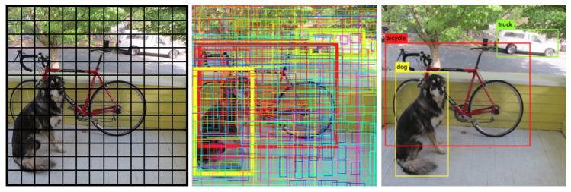

Ⅳ RELATED WORK OF DEEP LEARNING

* Deep Learning is a subset of ML, which on the other hand is a subset of AI. AI is a general term that refers to techniques that enable computers to mimic human behavior. ML represents a set of algorithms trained on data that make all of this possible. Deep Learning, on the other hand, is just a type of ML, inspired by the structure of a human brain.
* Deep learning algorithms attempt to draw similar conclusions as humans would by continually analyzing data with a given logical structure. To achieve this, **Deep learning technology uses neural networks containing thousands of layers which are capable of mimicking human level intelligence to distinguish anomalies, parts, and characters while tolerating natural variations in complex patterns.** In this way, deep learning merges the adaptability of human visual inspection with the speed and robustness of a computerized system.
* ***Deep learning*** teaches machines to do what comes naturally to humans to learn by example. New, low-cost hardware has made it practical to deploy a multi-layered “deep” neural networks that mimic neuron networks in the human brain. *This gives manufacturing technology amazing new abilities to recognize images, distinguish trends, and make intelligent predictions and decisions*. Starting from a core logic developed during initial training, deep neural networks can continuously refine their performance as they are presented with new images, speech, and text

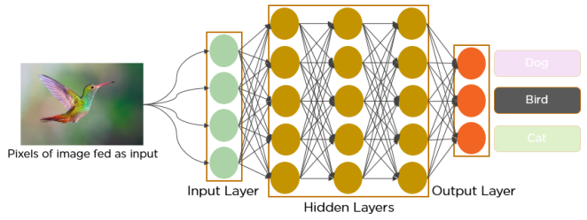

.

* The deep learning concepts ensures to make the image processing and the source code for in which the transmission of the input layer and the output layer to be clear in between the CNN and RNN neural network concepts for inspection or image detection algorithmⅤ RELATED WORK FOR GUN PARTS INSPECTION SYTEM

The main benefit of using an A.I. based gun parts inspection system is to reduce the time spent in checking these parts manually and to increase the accuracy of the product inspection process. Our product provides a feasible approach in this domain which helps in reducing the manpower used in the inspection process.

In this system we use YOLOv3 which is **fast and accurate in terms of mean average precision (map) and intersection over union (IOU) values as well**. It runs significantly faster than other detection methods with comparable performance.

The computerized object detection technology brings many benefits to the companies and **helps them deliver better experience and service to the users**. As the name implies, object recognition detects and identifies objects on the images. With the help of these technologies and a well organized dataset related to the gun parts which is our primary focus we can easily improve the accuracy of the system in the inspection process.

This methodology involves deep learning and computer vision technology in which it used to calculate the wide range of outcome source of the technical condition in the gun parts

In order to provide the correct detection we are using **YOLO-V3** this indicates the real object detection from the the particular part of the gun this provides high efficiency in detection or inspecting the parts of the gun

By using computer vision technology we can create a wide range of source in which a step by step procedure to inspect the things in which it is present in the guns as parts or any other defect part present in the gun

* In the first stage the gun part will be inspect by an inspecting camera and later it detect the image

* After the image inspection process gets over it later on move on to the object detection process

* Later on the data sets are collected in the system by the computer vision technology and detect the parts which are good and defective  in the system

* In The final process it checks the whether the object is good or fault

Finally the inspection system inspects the overall parts of the SRGM 76/52 machinery gun for marine navy army purposes in which it clearly gives us the output result which part is defected and about the information like a data set

In the Deep learning concept it later visualize that how the formulated object gets detected and later it collects the data sets from YOLO-V3 and then it gets back to the computer vision technology to identify the right path of the part is defected or good

Ⅵ ARCHITECTURE DIAGRAM AND DETAILED EXPLANATION

This is the module one architecture diagram which represents the YOLO-V3 structure and how the process is happening in the real time object detection

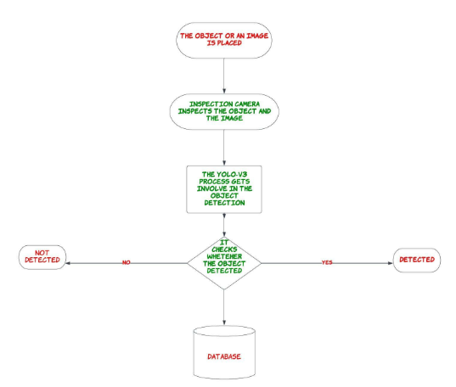

* This methodology clearly explains how the process undergoes each and every step in the form of identifying the real time objects in the case
* Whenever an object is detected this YOLO-V3 software predicts the data and directly send it to the system in a data set format
* After the dataset format gets collected it later on discussed about the formulated process involved in the memory access for the computer vision purpose
* The process of completion gets the overall result from the output from the dataset whether the object is detected or not

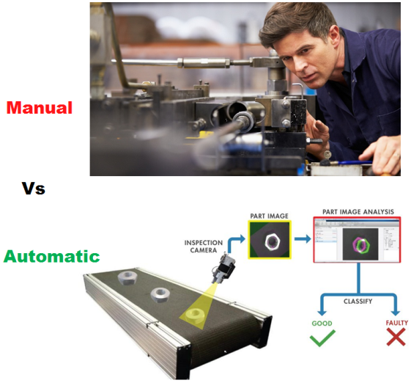

Ⅶ MODULE TWO ARCHITECTURE DIAGRAM AND EXPLANATION

The module 2 represent the architecture flow of the computer vision after the database is collected from the YOLO-V3 software and the data sets are extracted from the system to form the computer vision by openCV

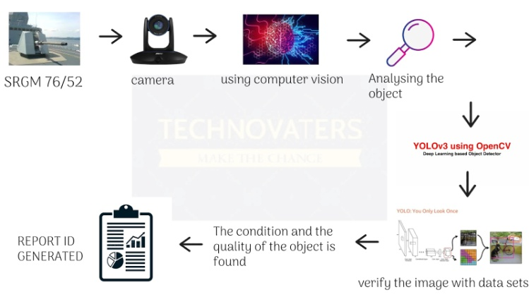

* This part clearly shows that how the data sets are extracted from the database and hence from the database the datasets are entered into the system for the analyzing of the object detection
* After the object gets detected in the source by which the YOLO-V3 it later on now detects what are the parts that involves in the big machinery guns
* These parts are very critical to identify whether they are in defected or good by using computer vision we can clearly identify the parts present in the machinery guns
* It later on gives the clear cut output by which the part is defected or else it is good in condition
* This provides even though for military purposes weapon detection by using CNN and RNN technical purpose

This is an example in this rifle the parts that are come as outcomes in which these are the parts present in the rifle and thus by computer vision and YOLO-V3 it detects the object and parts gives the output as which is defected and good

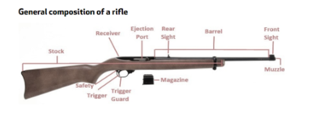

Ⅷ RESULT AND CONCLUSION

The result is said to be the complete overview of the project to the undercover of the military purposes and also to the navy army for the detection of weapon and parts by using the computer vision technology and the deep learning format it mainly involves the source in which the detection algorithm with the YOLO-V3 module involves the overall coverage of the

Gun parts detection and the rectification

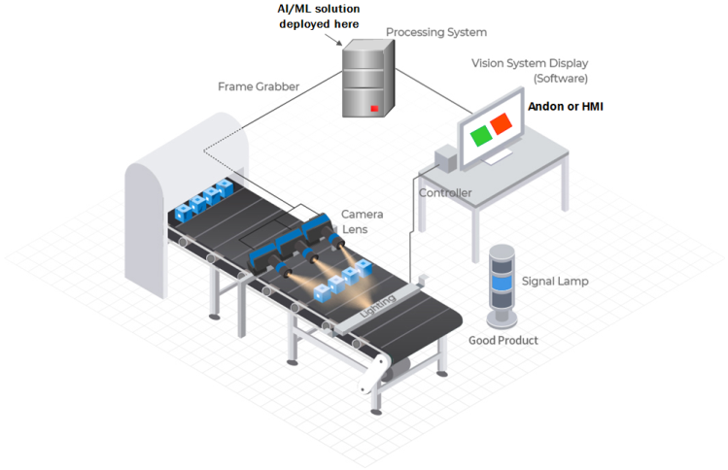

*{ }*

ACKNOWLEDGMENT

The main advantage of the module to precautionary until the weapon or the opposite offence army to attack with the weapon that detected by the object and later on it detect the parts involve in the weapon of an example SRGM 76/52

REFERENCES

[1]Verma, Gyanendra & Dhillon, Anamika. (2017). A Handheld Gun Detection using Faster R-CNN Deep Learning. 84-88. 10.1145/3154979.3154988.

[2]Sanam Narejo, Bishwajeet Pandey, Doris Esenarro vargas, Ciro Rodriguez, M. Rizwan Anjum, "Weapon Detection Using YOLO V3 for Smart Surveillance System",

[3]T. S. S. Hashmi, N. U. Haq, M. M. Fraz and M. Shahzad, "Application of Deep Learning for Weapons Detection in Surveillance Videos," 2021 International Conference on Digital Futures and Transformative Technologies (ICoDT2),

[4] Warsi, M. Abdullah, M. N. Husen, M. Yahya, S. Khan and N. Jawaid, "Gun Detection System Using Yolov3," *2019 IEEE International Conference on Smart Instrumentation, Measurement and Application*

*[5]D. Chen, G. Cao, H. Fan and D. Wang, "Design and implementation of detecting instrument for an airborne gun fire control computer," 2012 IEEE International Conference on Mechatronics and Automation, 2012,*

[6]H. Jain, A. Vikram, Mohana, A. Kashyap and A. Jain, "Weapon Detection using Artificial Intelligence and Deep Learning for Security Applications," *2020 International Conference on Electronics and Sustainable Communication Systems (ICESC)*, 2020, pp. 193-198,

[7]Hindawi Mathematical Problems in Engineering Volume 2021, Article ID 9975700,

[8]Yuan, J.; Guo, C. A deep learning method for detection of dangerous equipment. In Proceedings of the Eighth International Conference on Information Science and Technology, Granada, Cordoba, and Seville, Spain, 30 June–6 July 2018; pp. 159–164.